Lesson 6 Demo 2: Create and Manage Teams and Users

This section will guide you to:

* Create and manage an organization
* Create and manage teams in an organization
* Create and manage users in a team

This lab has three subsections, namely:

1. Creating an organization
2. Creating and managing teams in the organization
3. Creating and managing users in a team

**Note:** You can perform this demo with MKE web UI, provided you've a license for it. However, Mirantis isn't providing the free license currently, leading to limited or disabled use of some of the MKE features.

**Step 1:** To create and manage teams, you need to create an organization, as teams are collectively a part of an organization

* Sign in to your **Docker Hub** account and navigate to **Organizations**
* Click on **Create Organization** if you don’t have any existing ones

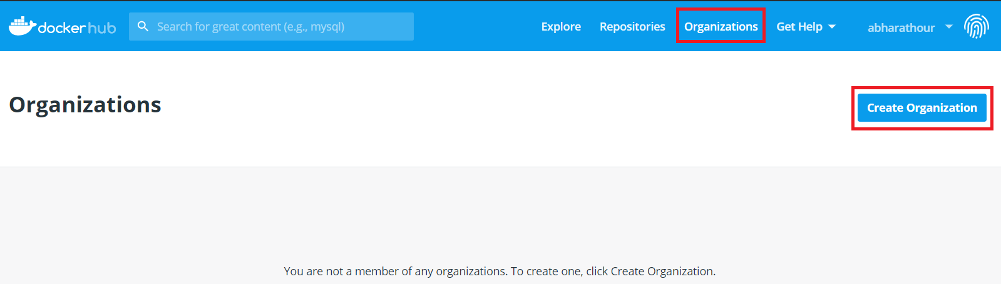

* Fill all the necessary details, and click on **Create Organization** to create an organization

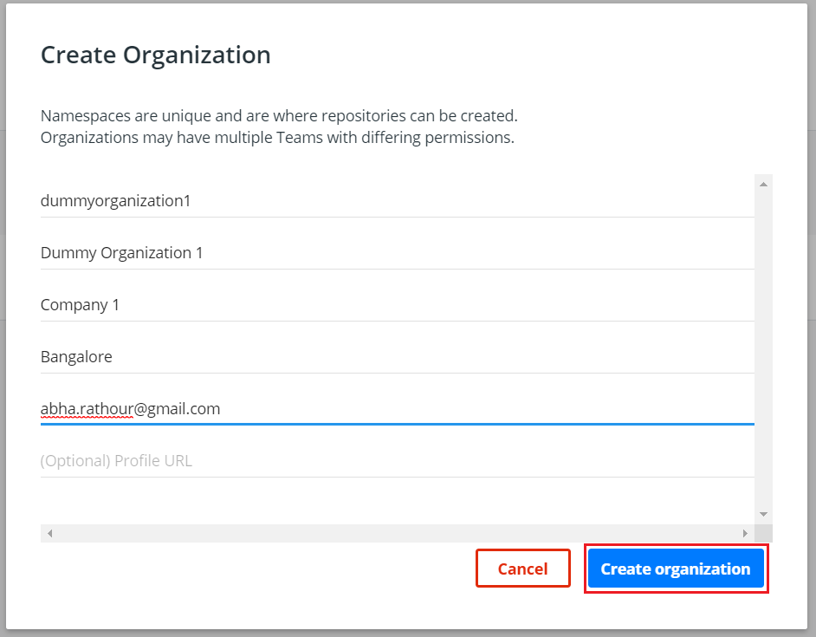

* Click on the newly created organization name to view details like its members and teams

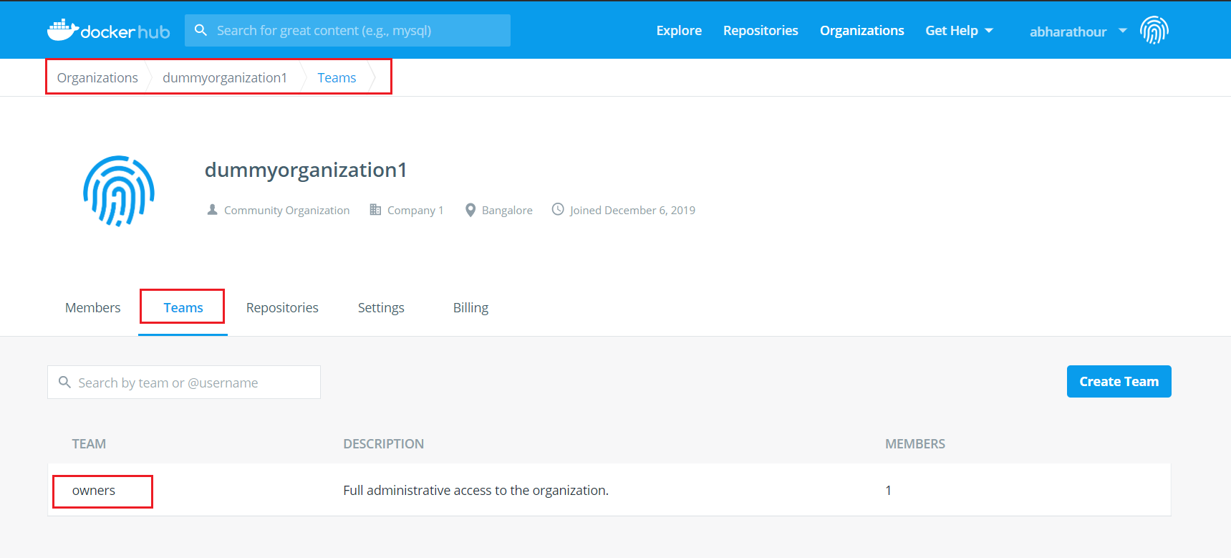

**Step 2:** Create and manage teams in an organization

* Navigate to **Teams** tab in an organization, and click on **Create Team**

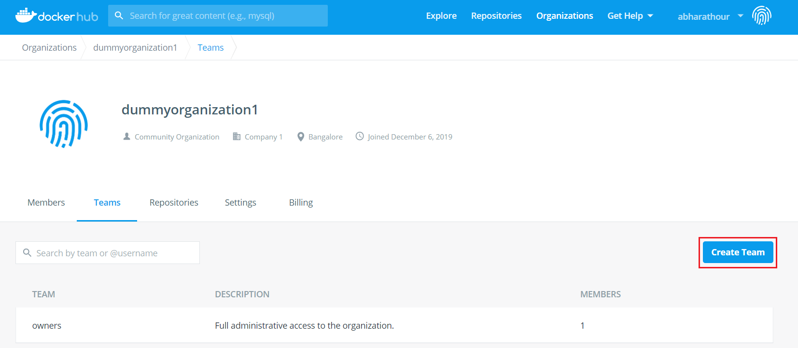

* Fill the nameand descriptionof the team, and click on **Create**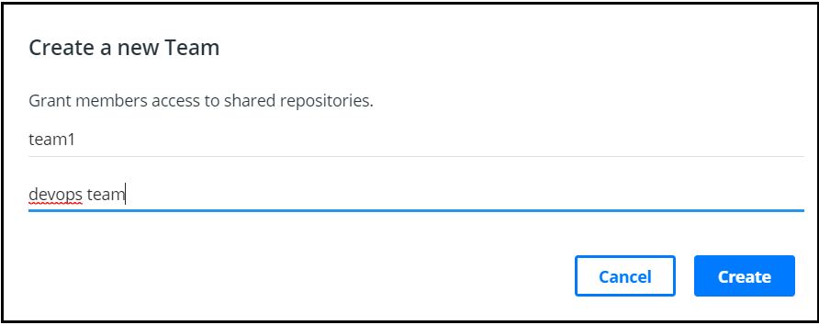

**Step 3:** Create and manage users in a team

* Create a new user by clicking on the **Add Member** button

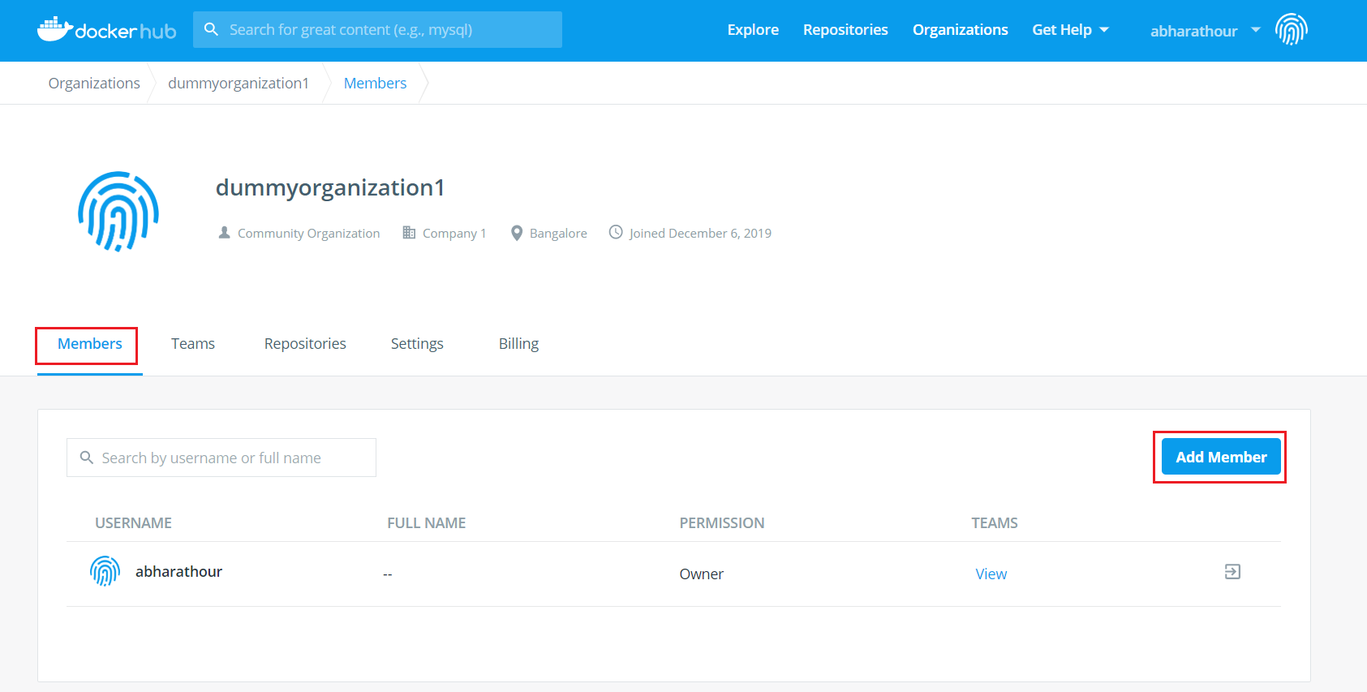

* Fill details like the user’s Docker ID or email, select the team you wish to join from the dropdown, and click on **Add**

